Bachelor of Business Administration (B.B.A)
Teacher name: Dr Rajinder Deswal Semester 1st
Lesson Plan : Lesson Plan November to February
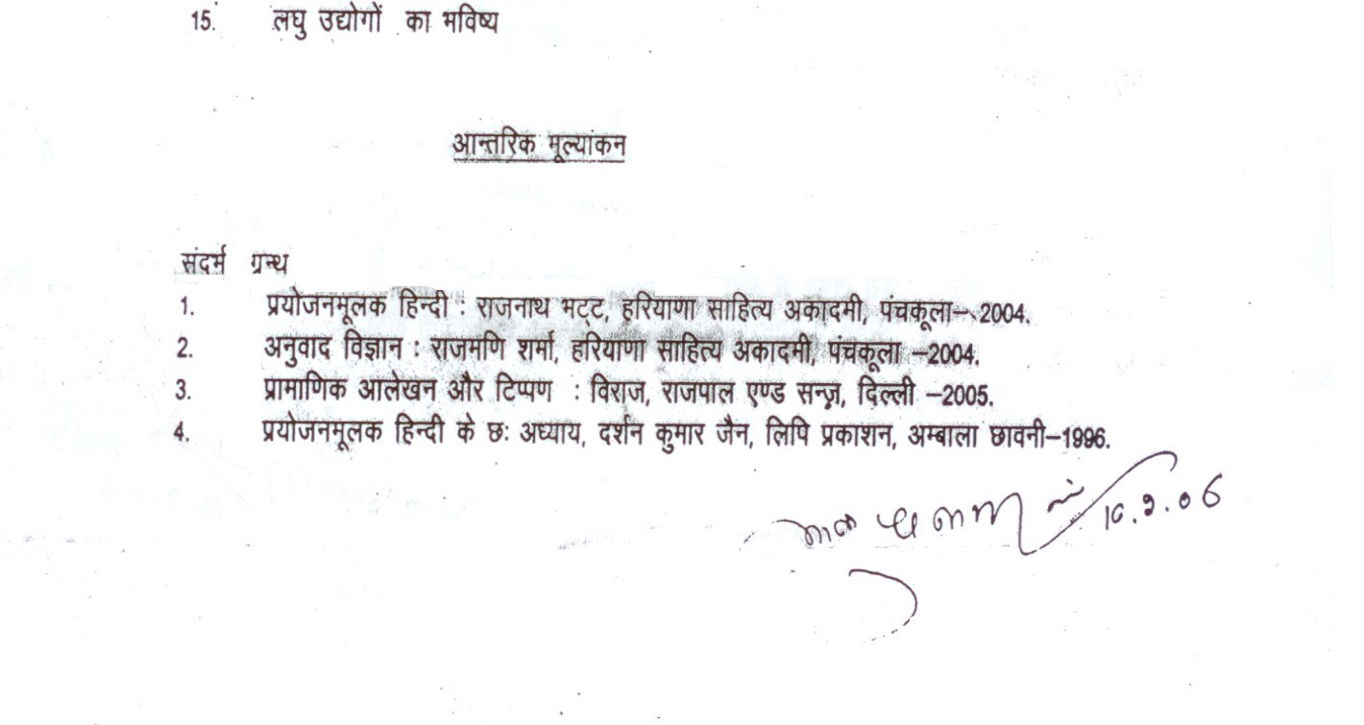
In November First two topics, in December 3,4,5 topic , In January 6, 7, In February 8, 9, 10.

