PERSONAL INFORMATION
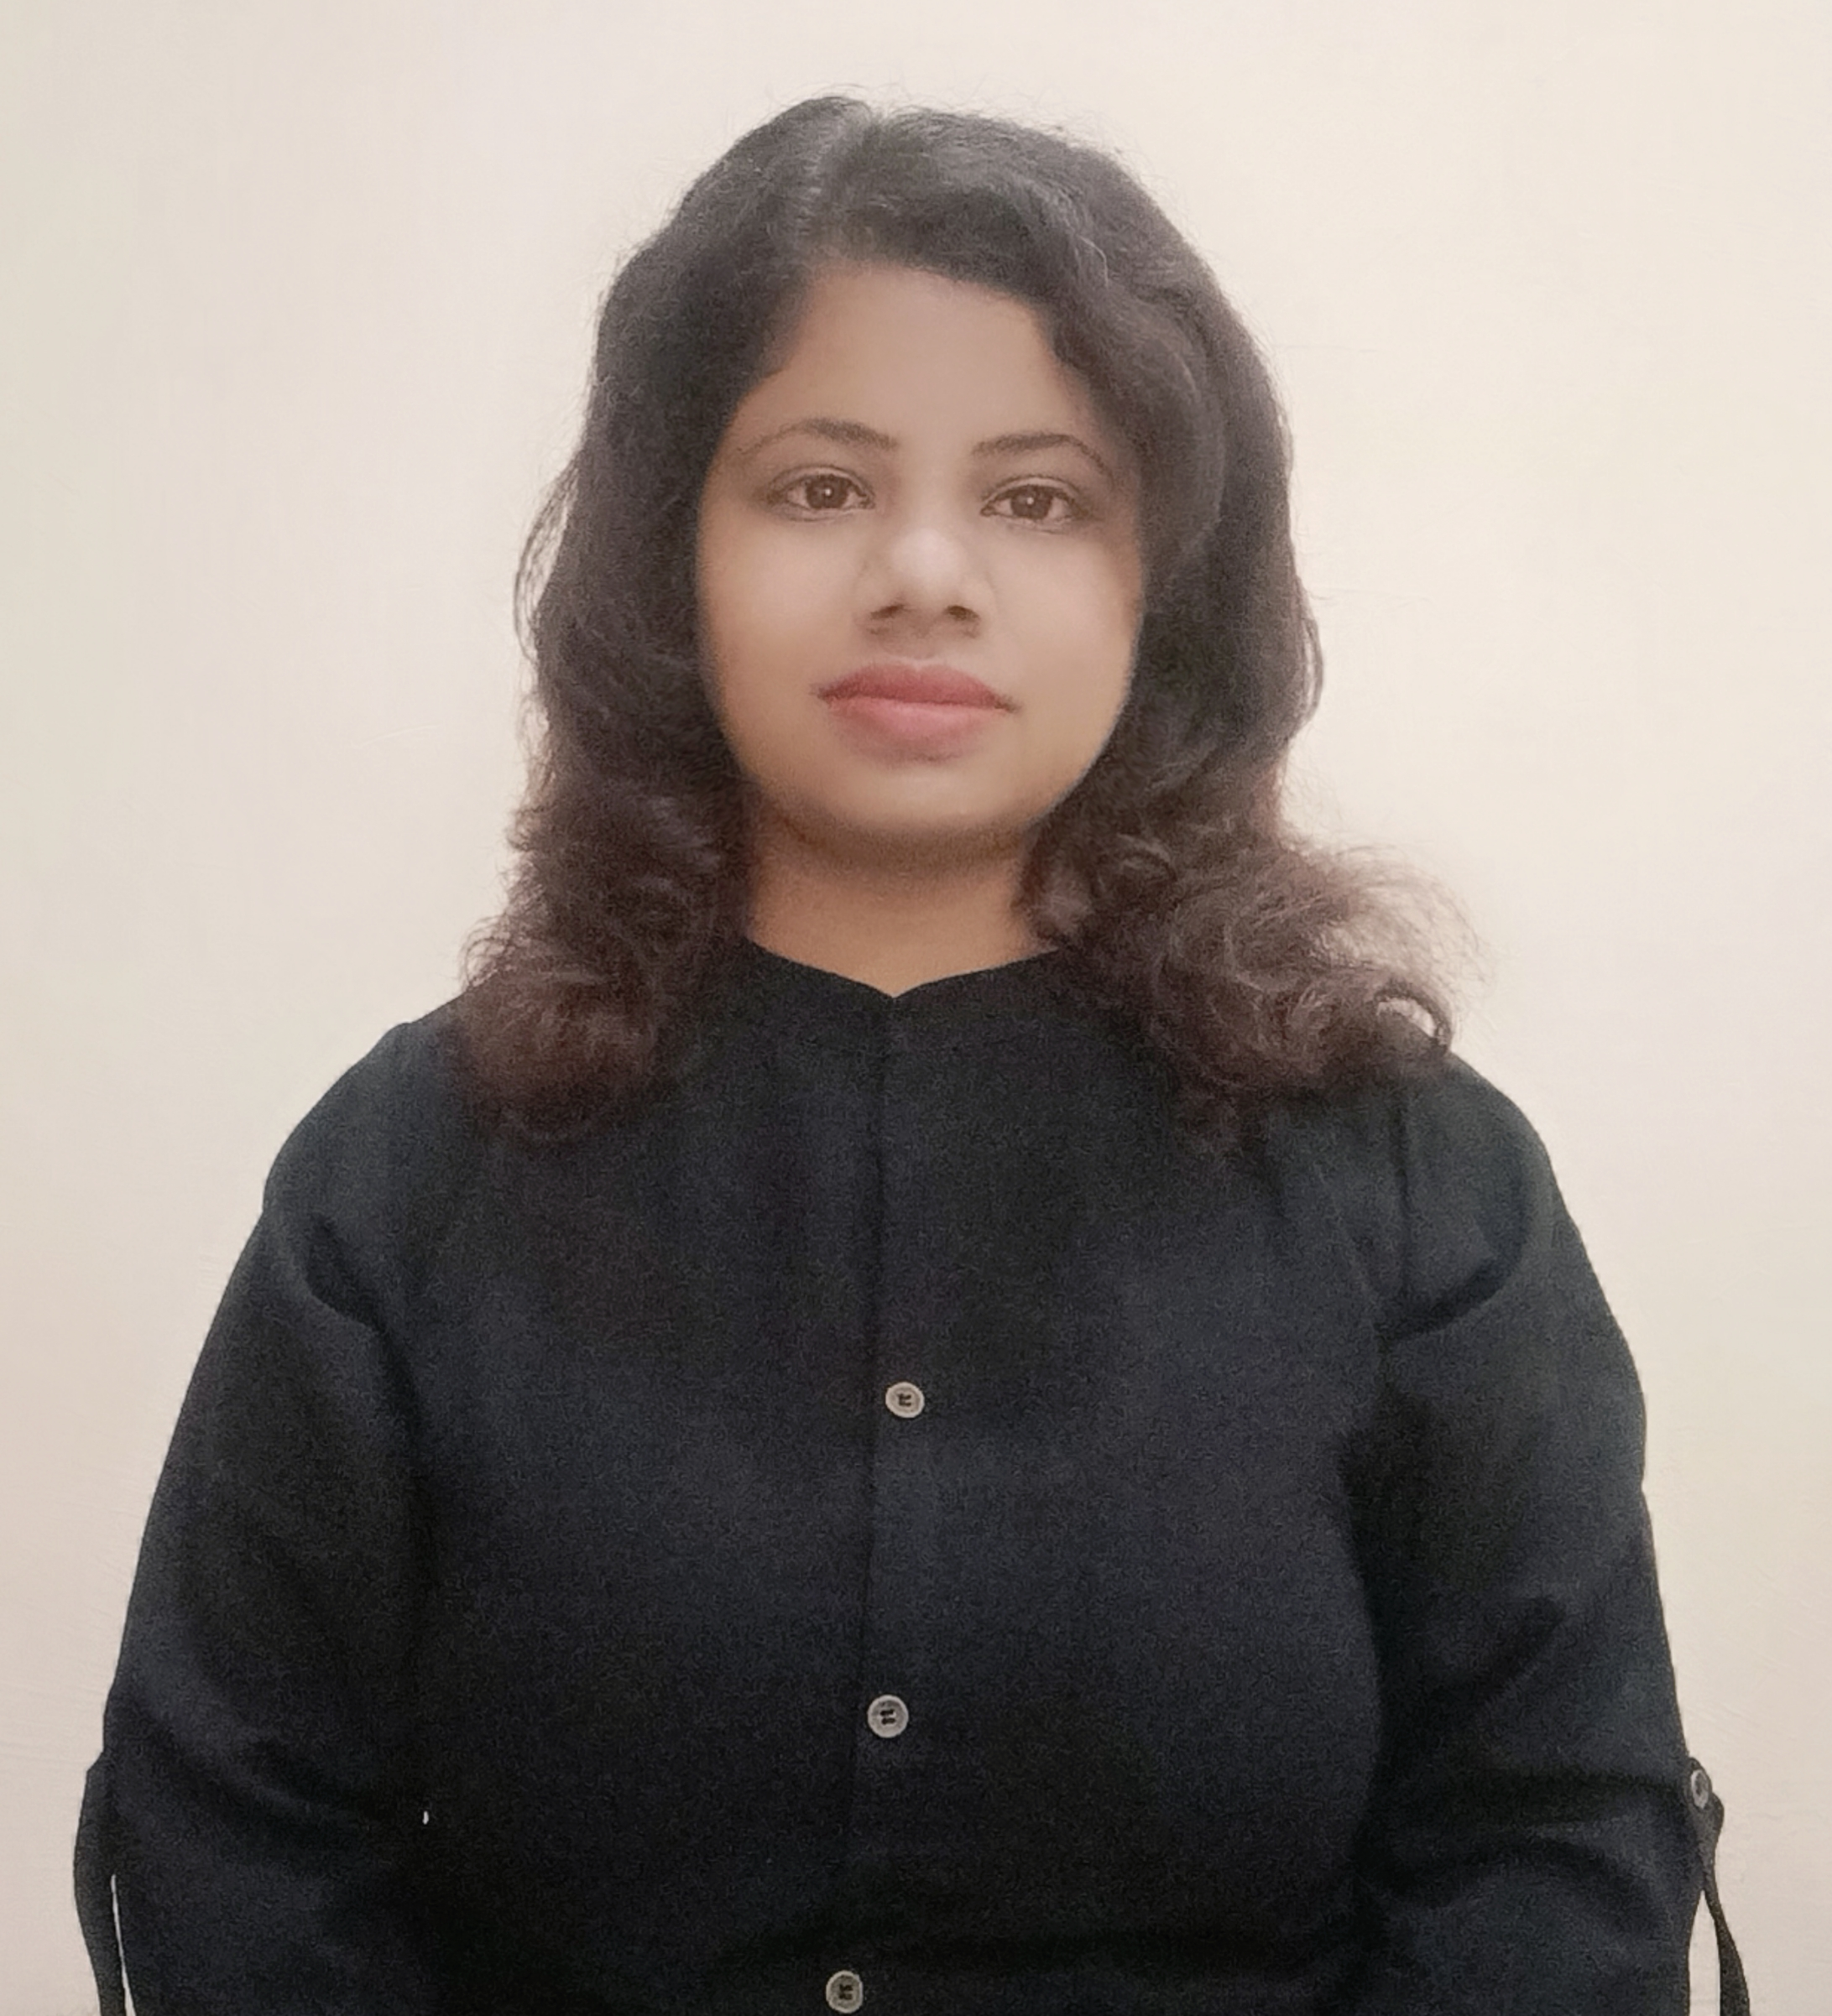

Reetika
230-31, R.A. Bazar
Ambala Cantt
Haryana
+91-9729678613
riya0612@gmail.com

Date of Birth: December 6th, 1989
Place of Birth: Ambala, Haryana
Citizenship: Indian
Gender: Female

OBJECTIVE

Seeking responsibility and challenging opportunity that would utilize and encourage my abilities through dedicated hard work and resources of the institution to achieve combine growth.

PROFILE SUMMARY
• Thorough understanding of the subject
• Well skilled in communication and comprehension

EDUCATION
M.Com
Kurukshetra University, Kurukshetra, Haryana
MCA
Kurukshetra University, Kurukshetra, Haryana
M.Sc(CS)
Kurukshetra University, Kurukshetra, Haryana
MA Economics ( Pursuing)
Kurukshetra University, Kurukshetra, Haryana
PGDCA
Kurukshetra University, Kurukshetra, Haryana
B. Com (Tax Procedure & Practices)
Kurukshetra University, Kurukshetra, Haryana
B. Ed
Kurukshetra University, Kurukshetra, Haryana
UGC NET (Commerce) Qualified
6 month .net training from CS InfoTech, Chandigarh.

EMPLOYMENT HISTORY
Assistant Professor (Commerce), January 2019 to April 2019
G.M.N. (PG) College, Ambala Cantt

RESPONSIBILITIES
• Delivered scheduled lectures to UG and PG students.
• Collected educational information and taught to students during classes.
• Conveyed subject matter and lecture to the students in a creative way.
• Evaluated the students individually to identify areas of difficulties.
• Ensured completion of assigned syllabus within the time-frame given.
SKILLS
Eloquent
Mastery of subject matter
Major Fields: Accounts and Management
Able to recognize positive and negative behaviour of students
Ability to identify students’ weak areas

